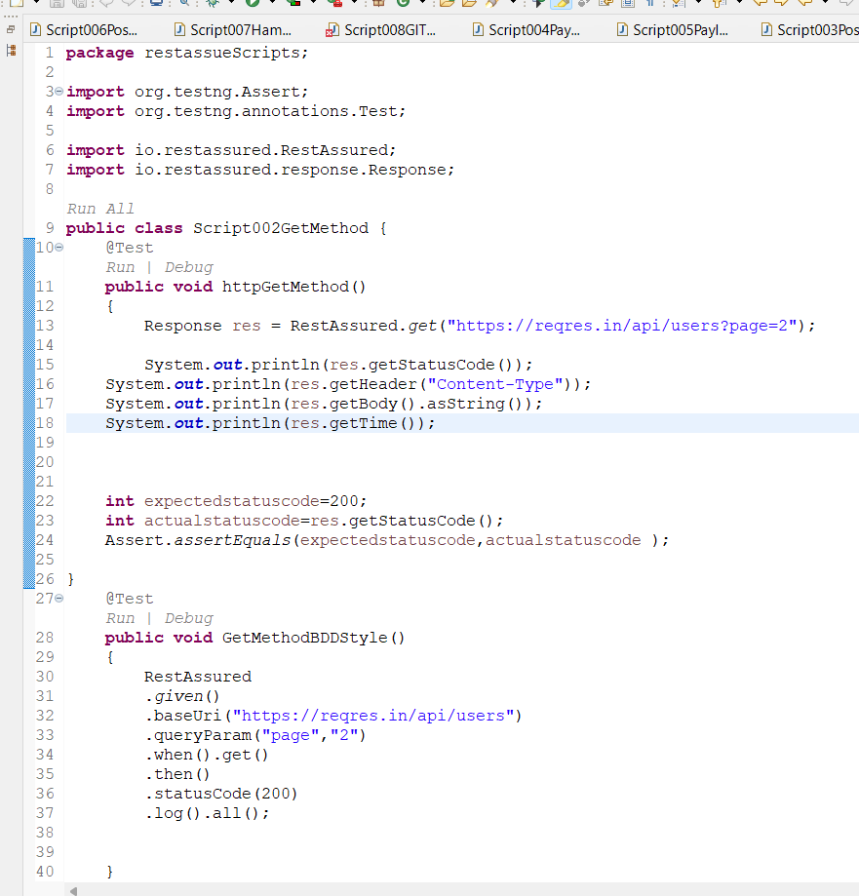

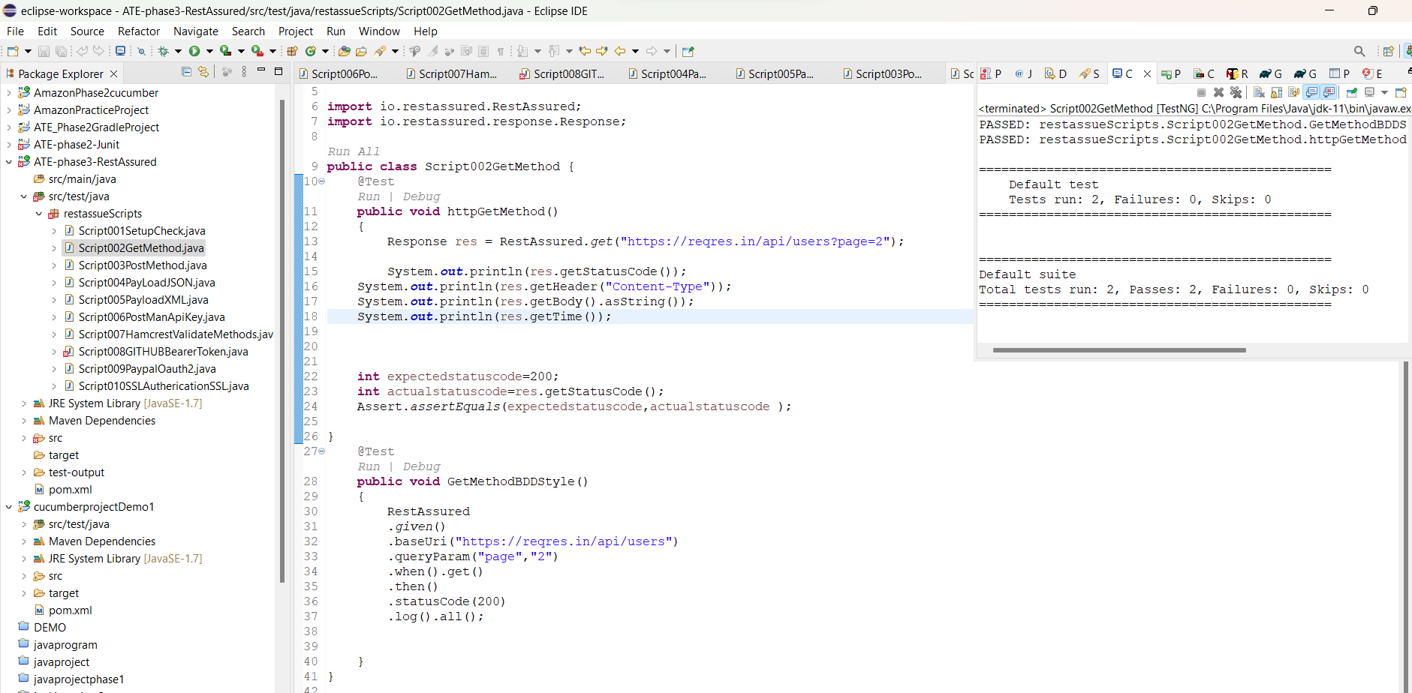

**Click on run button.**

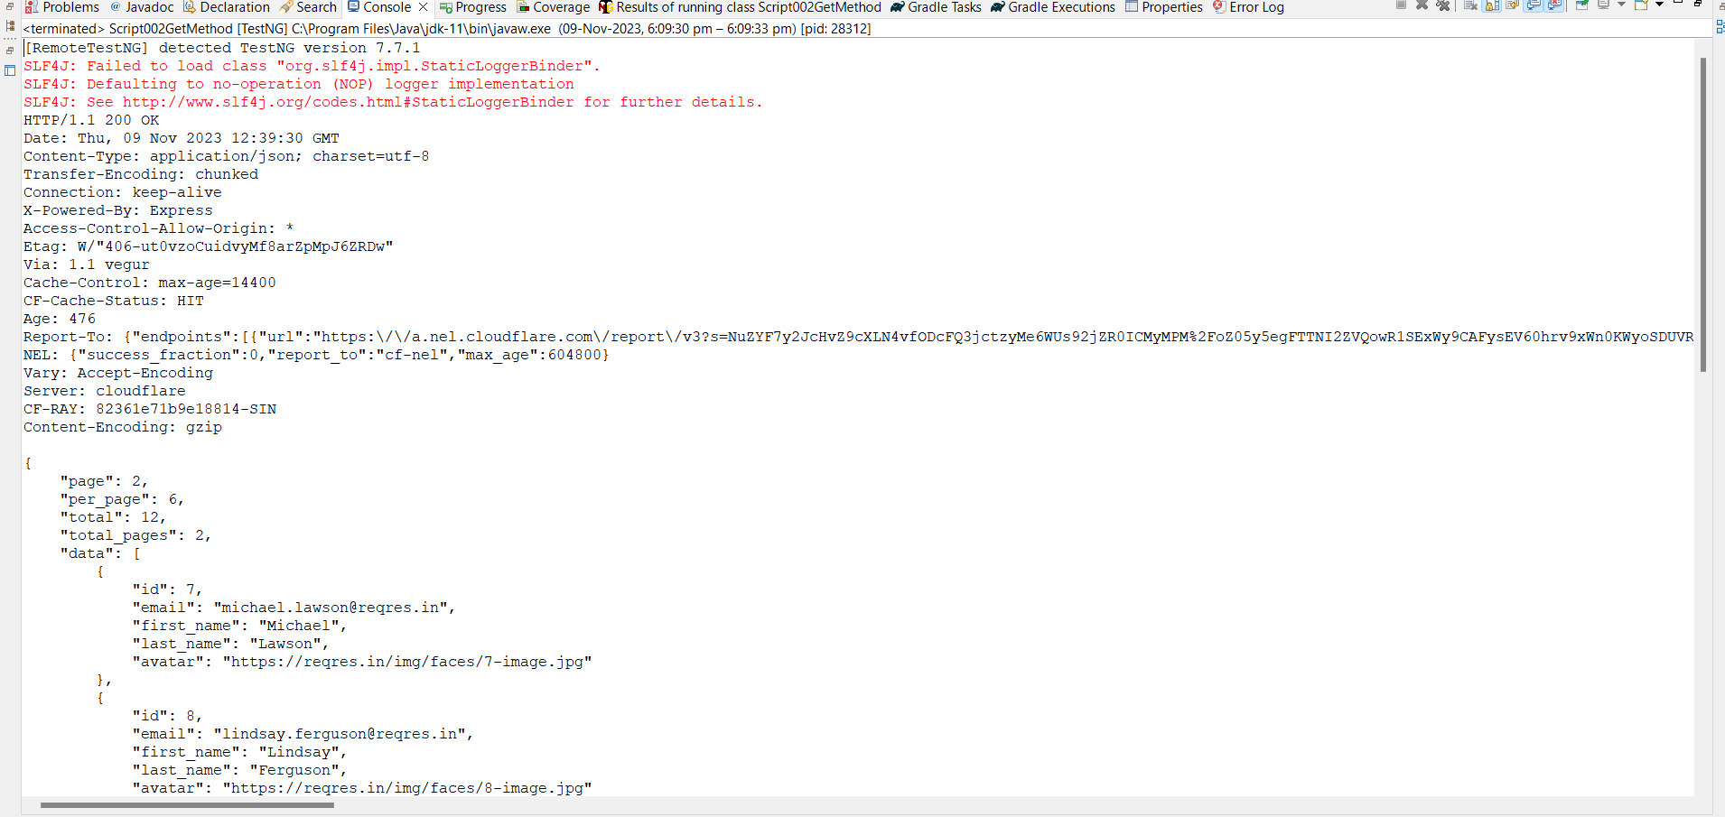

**code:-**

**package** restassueScripts;

**import** org.testng.Assert;

**import** org.testng.annotations.Test;

**import** io.restassured.RestAssured;

**import** io.restassured.response.Response;

**public** **class** Script002GetMethod {

@Test

**public** **void** httpGetMethod()

{

Response res = RestAssured.*get*("https://reqres.in/api/users?page=2");

System.***out***.println(res.getStatusCode());

System.***out***.println(res.getHeader("Content-Type"));

System.***out***.println(res.getBody().asString());

System.***out***.println(res.getTime());

**int** expectedstatuscode=200;

**int** actualstatuscode=res.getStatusCode();

Assert.*assertEquals*(expectedstatuscode,actualstatuscode );

}

@Test

**public** **void** GetMethodBDDStyle()

{

RestAssured

.*given*()

.baseUri("https://reqres.in/api/users")

.queryParam("page","2")

.when().get()

.then()

.statusCode(200)

.log().all();

}

}